Software Engineering CS-303 Name: Roll Number: Sec:

Time Allowed: 40 minutes Quiz # 3 23rd October, 2019

1. Use the information given below to answer the following questions.

My Cute Bank (MCB) has approximately 1500 branches all over Pakistan that use a computerized MCB banking system for daily banking activities. The branches are connected with their Head Office (HO) in Karachi and communicate with the HO at least twice a day. At start of each working day every branch has to mark start of the day through the computerized banking system and update its record from the HO to make the branch’s records consistent with the records at the HO. Similarly, at the end of each working day every branch has to mark end of day. At end of day every branch sends complete information regarding the day’s transactions to the HO and the HO updates its records related to customer accounts and the branch’s status. Normally, the branches and the HO do not necessarily need to communicate with each other through the computerized banking system from start of the day to end of the day.

Approximately 80% branches have ATMs connected with them which accept MCB ATM cards only. During a day, ATM transactions on a machine connected with a branch are managed by the branch. During each ATM transaction, the branch contacts all other branches to determine the total amount of cash withdrawn in this day against a particular ATM card. This information is used to approve or disapprove a particular user request for cash withdrawal when the daily limit is exceeded for a particular card.

The HO also keeps record of branches that have or have not updated themselves at 8:55 AM on each working day. Using the computerized banking system a Support Engineer at the HO sends a message to Branch Manager if the manager’s branch has not updated itself till 8:55 AM on a working day.

1. Assume that MCB banking system is currently operational in the following cities only: Karachi, Lahore, Peshawar, Quetta, Islamabad, Faisalabad, and Haiderabad. There is only one branch of MCB in each of these cities including Karachi. In addition, head office of MCB is located in Karachi. All branches except Haiderabad and Faisalabad branches have ATM machines attached with them.

Draw, using boxes and arrows, the architecture diagram for the given scenario using the relevant information in the problem statement as well as information given in part a. While drawing this diagram, use all suitable architectural styles.

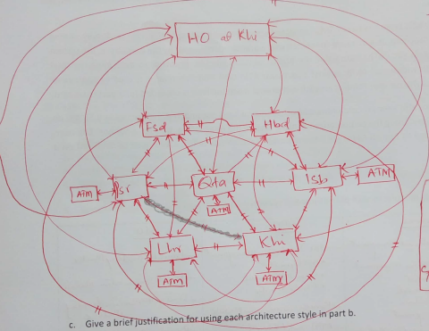

Give a comma separated list of all the architectural styles used in diagram of part b. Give a brief justification for using each architectural style.

Architectural styles used: **Client/Server + Centeralized Architecture**

1. Royal Bank of Kuwait (RBK) needs a banking application that allows its customers to maintain their bank accounts. The system should allow a customer to view account balance and shop online using the bank account number. Customer can also view the status of the account and change currency of his/her bank account. Some other tasks that a customer should be able to perform include Pay Bills, Transfer Funds (to same or other banks), Request Chequebook Generate Mini Statement, Generate Account Statement for particular period (period not exceeding 1 year), Generate Transaction PIN, Add/Remove beneficiary for fund transfers, and Request Bank draft/Pay Order.

The account statement of last 3 years can be requested through this application, the customer must visit bank in order to get more than 3 years old bank statement. Funds Transfer, Bill Payment, Online Shopping should be processed instantly. The account balance should reflect each of these activities within 5 seconds of request.

RBK expects that once the application is developed, their Customers can login through their unique account number and a strong password. But a customer cannot create his account, only Admin, residing in Head Office of RBK, will create new account of a customer. The Admin creates an account on recommendation of a Branch Manager who uses the same banking system to send the recommendations for opening an account. The Branch Manager enters customers’ details in respective recommendations and sends the recommendations to create new accounts before the end of the day. Admin must ask the customers to verify their emails before end of the next working day. Account creation will be successful only if a customer verifies an email address by using the link sent during account creation process. Once the email is verified the Admin creates the account and provides a customer a unique login id through a verified email. The password is generated once account creation is successful, but the password is not shared through the RBK banking system. The customer must change the password at first login and password (of minimum length 8) must contain at least one capital alphabet of English, one small alphabet of English, one special character, and one digit. Admin will also be able to update/delete account of a customer, if recommended by the Branch Manager.

The bank also plans to provide these banking services to mobile users after successful launch of this web based application.

**To do:**

If you were a developer of the RBK banking application, which architecture would you use? Draw the architecture diagram, using appropriate architecture styles. Give reasons

**Layered Architecture**

1. Why is it important to neither under-modularize nor over-modularize the design of a software application?

**Under-modularization results in modules that are large in size and, therefore, difficult to build and maintain. Over-modularization, on the other hand, results in modules that are small in size. This increases the cost and effort of integrating these modules.**

1. Use the following partial design class diagram of a campus management system to answer the questions given below. Justification of answers must be provided to get credit.

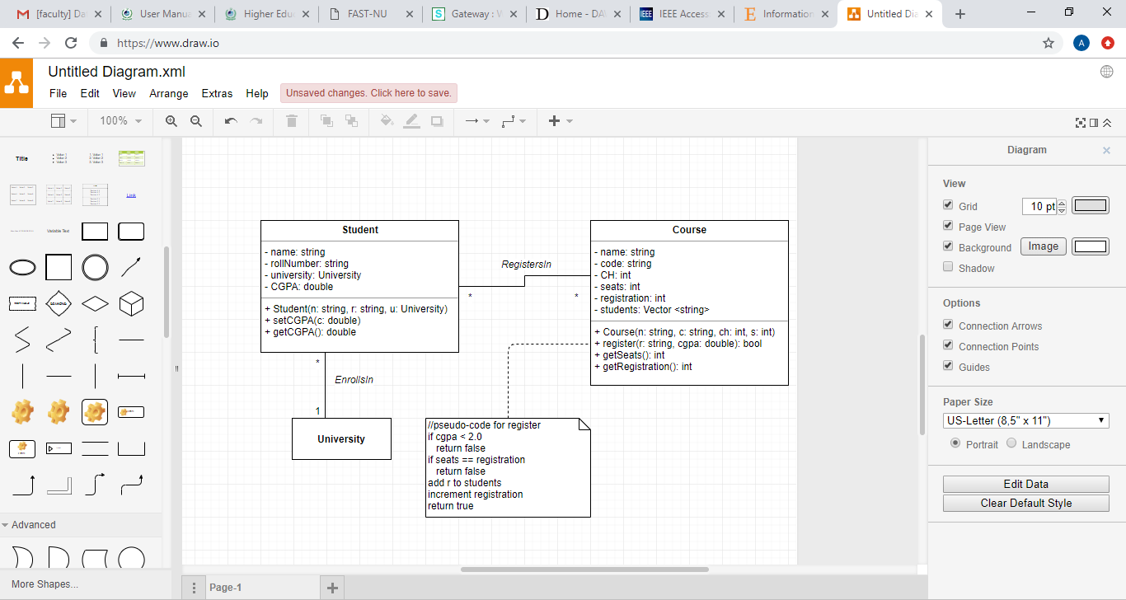

1. What type of cohesion will be exhibited by the set and get functions of the Student class?

**Perfect cohesion (or functional cohesion) because these set and get functions are expected to be atomic i.e. contain just one statement (or perform just one task).**

1. What type of cohesion is exhibited by the Course class?

**Communicational/informational cohesion because all course-related data and operations are encapsulated in the Course class.**

1. What types of coupling are explicitly present between the Student and University classes?

**1. Common coupling because the university attribute of the Student class has data type University.**

**2. Stamp coupling because University is the data type of the u argument of the constructor of the Student class.**

1. What types of coupling does the register operation of the Course class suffer from?

**1. Data coupling because two simple/unstructured arguments (r and cgpa) are passed to it.**

**2. Control coupling because the value of cgpa determines the flow of control within the register operation.**